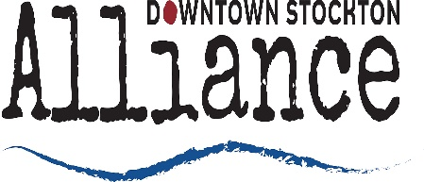

Downtown Stockton Alliance Board of Directors Meeting Minutes
Wednesday, April 18, 2018 at 3:30 pm
125 Bridge Pl 3rd Fl. Stockton, CA

Board of Directors Present: Chair Giovanni Trinchera, Vice-Chair Kendra Clark, Treasurer Wes Rhea, Secretary Jared Rusten, Micah Runner, Megan Cort, Matt Amen, Jasmine Leek, Kari McNickle, Paula Sheil
Board of Directors absent: Debbie Vallejo, Anthony Barkett, Mahala Burns, Marcia Cunningham

Staff: Mike Huber, Courtney Wood, Charisse Lowry

Minutes
- Call to Order/Roll Call
- Meeting was called to order at 3:35pm
- Public Comments
- No Comments
- Approval of Financial Statements and Minutes – Action Item
- M. Huber reported on the amended budget that he had been working on. Adjustments were made to workers comp and payroll taxes. He explained that he would not be hiring an Operations Manager. The Ambassadors will pair up with the maintenance tech and start taking on additional responsibilities and duties. Mike stated that he had reallocated funds for new maintenance vehicles. Mike stated that we needed better line item accounting for end of year expenses so that they don’t roll into the New Year budget. The $5000 that was allocated for the downtown trolley will be moved and used for another program. Discussion on budget format. The new format should contain a run rate, last year’s budget and this year’s projected budget.
- A motion was made by (M. Runner/J. Leek) to approve the minutes but to wait on approving the financials until May’s meeting. The motion was passed unanimously
- Discussion on Amended Budget & New Formatting for Financials – Information Item
- Item moved to next meeting
- Committee Reports
- W. Rhea reported on the new look for the website as well as all ads will be visual, and no more print ads.
- Consideration of New Board Members – Action Item
- G. Trinchera reported on the new candidates for the Board of Directors. Brief discussion on candidates and how candidates are chosen for the board.
- On Boarding New Board members in May – Information Item
- W. Rhea discusses how new directors should be familiarized and given an overview of who, what, where and how the DSA exists.
- Discussion on Electing Chairs for Clean & Safe and Economic Development Committees – Action Item
- Item moved to next meeting
- Future Items for Consideration
- No Items
- Adjournment
- Meeting adjourned at 4:27pm

